**News Release**  
Contact: Melinda Merillat  
Public Relations & Corporate Communications  
[melinda.merillat@cbshouston.edu](mailto:melinda.merillat@cbshouston.edu)

832.252.0745



**FOR IMMEDIATE RELEASE**

**June 23, 2022**

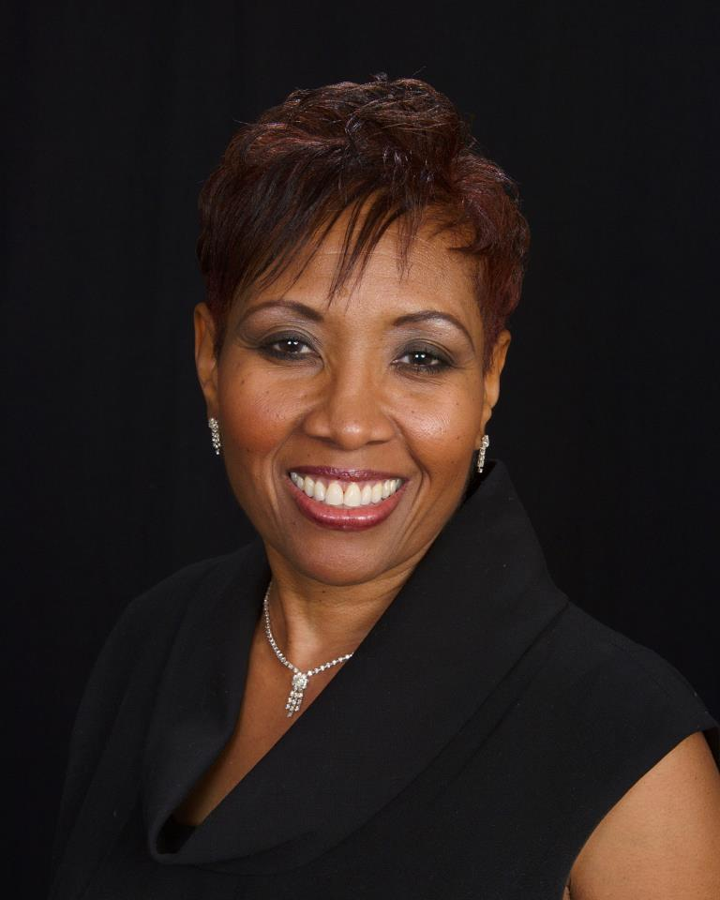**The College of Biblical Studies Welcomes Dr. Lisa Stewart as Vice President of Discipleship**

The [College of Biblical Studies](https://www.cbshouston.edu/) welcomes Dr. Lisa Stewart as the vice president of discipleship on their Houston campus at 7000 Regency Square Blvd. Dr. Stewart will replace Dr. Paul Nyquist who is retiring later this month.

CBS is committed to providing biblical training that translates into life-transforming knowledge and service to God. The CBS Discipleship department is committed to this transformation through the intentional discipleship of every CBS student, staff member, and faculty member.

Dr. Bill Blocker, president of the College of Biblical Studies believes authentic servant leadership begins with discipleship. “Our discipleship initiatives not only represent creative thinking that can propel CBS to the forefront of models for educational institutions, but also faithfully transforms lives of students who will significantly impact the world for Christ.

In her new role, Dr. Stewart will oversee the spiritual formation of students, faculty, and staff of the college. Such oversight will involve discipleship, counseling, and spiritual guidance for each group, along with organizing student and staff chapels. Her team will also conduct spiritual and cultural assessments and seek accountability internally and externally through other Christian organizations.

“Dr. Paul Nyquist laid a wonderful foundation for the development of the discipleship department. I was blessed to serve under his leadership and alongside the great discipleship team,” said Dr. Stewart. “My personal desire is to impart wisdom and guidance that inspires and motivates others to answer the call God has on their lives and serve in a manner that brings glory and honor to the Lord.”

**About the College of Biblical Studies**

The [College of Biblical Studies](http://www.cbshouston.edu/) is in Houston, Indianapolis, and Fort Wayne. Leveraging its academic rigor and biblical worldview training, CBS offers an accredited college education on-campus and online, with several programs offered in the Spanish language. Students receive transformational education and training for service to families, ministries, businesses, and communities around the world. CBS has provided biblically based education to more than 26,000 students since 1976 and is ranked as one of the lowest tuitions in Texas.

###